**CODE**

#include<stdio.h>

#include<graphics.h>

#include<conio.h>

#include<math.h>

void main()

{

int gd = DETECT, gm, x1,y1,x2,y2,lx,ly,dy,dx,pk,i; initgraph(&gd,&gm,"c:\\tc\\bgi"); printf("put the values of x1 and y1\n");

scanf("%d %d",&x1, &y1);

printf("put the values of x2 and y2\n");

scanf("%d %d",&x2, &y2);

dx=abs(x2-x1)

;

dy=abs(y2-y1)

* if(x2>x1)

{

lx=1;

}

else

{

lx=-1;

}

if(y2>y1)

{

ly=1;

}

else

{

ly= -1;

}

putpixel(x1,y1,RED);

if(dx>dy)

{

pk=2*dy-dx; for(i=0; i<dx; i++)

{

if(pk<0)

{

x1=x1+lx;

y1=y1;

pk=pk+2*dy;

}

else

{

* =x1+lx;

y1=y1+ly

;

pk=pk+ 2*dy-2*dx;

}

putpixel(x1,y1,RED);

}

}

else

{

pk=2*dx-dy; for(i=0; i<dy;i++)

{

if(pk<0)

{

x1=x1;

y1=y1+ly;

pk=pk+2*dx;

}

else

{

x1=x1+lx;

y1=y1+ly;

pk=pk+2*dx 2*dy;



}

putpixel(x1,y1,RED);

}

}

getch();

closegraph ();

}

**OUTPUT**

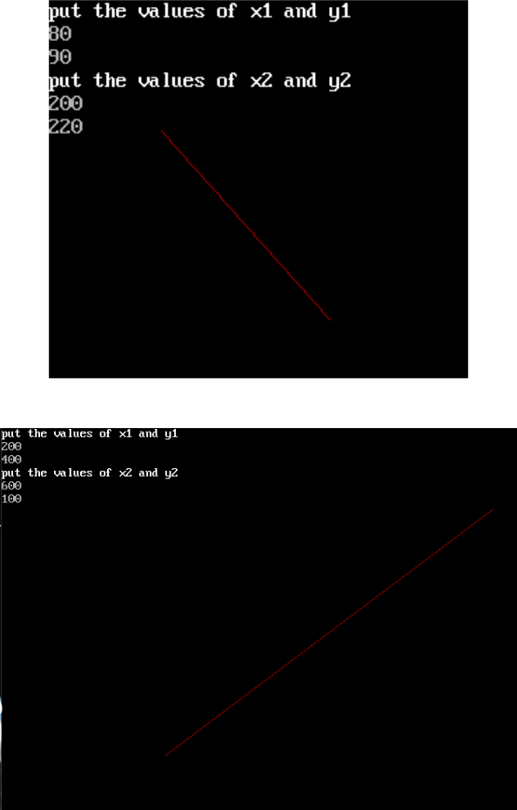

**DISCUSSION**

In this lab, we utilized Bresenham's Line Algorithm (BLA) to generate straight lines. The algorithm was implemented using the C programming language and Turbo C, along with its directory file. We explored the principles behind drawing lines, which can be further modified to create complex structures.

**CONCLUSION**

Therefore, the BLA algorithm was utilized to draw a line